PROJECT REPORT OF INDUSTRY ORIENTED HANDS-ON EXPERIENCE (IOHE)
ON
Cloud-Based Industrial Digital Twin Platform for IoT-Integrated 3D Asset Monitoring and Predictive Analytics
submitted in partial fulfilment of the requirements for the award of degree of

BACHELOR OF ENGINEERING
In
COMPUTER SCIENCE AND ENGINEERING
Submitted by: Supervised By:
Sparsh Mittal Prof. Dr. S. B. Goyal
2210990865 Dean
Payal Chitkara University
2210992037
Arshpreet Singh
2210991370

DEPARTMENT OF COMPUTER SCIENCE AND ENGINEERING
CHITKARA UNIVERSITY
CHANDIGARH-PATIALA NATIONAL HIGHWAY, RAJPURA, PUNJAB, INDIA
CONTENTS

S.no. | Title | Page No.
1 | Declaration | 3
2 | Acknowledgement | 4
3 | Abstract | 5
4 | Introduction | 6
5 | Methodology | 8
6 | Tools and Technologies | 11
7 | Implementation | 13
8 | Major Findings / Outcomes | 15
9 | Conclusion and Future Scope | 17
10 | References | 19

DECLARATION

We hereby certify that the work which is being presented in the project report entitled “Cloud-Based Industrial Digital Twin Platform for IoT-Integrated 3D Asset Monitoring and Predictive Analytics” in partial fulfilment of requirement for the award of the degree of Bachelor of Engineering (Computer Science and Engineering) submitted in the department of Computer Science and Engineering at Chitkara University Institute of Engineering and Technology, Chitkara University, Punjab, India, is an authentic record of my own work carried out under the supervision of Prof. Dr. S. B. Goyal. The matter presented in this project report has not been submitted in any other university/institute for the award of any degree

Place: Hyderabad Sparsh Mittal
Date: 31/03/2026 2210990865
Payal
2210992037
Arshpreet Singh
2210991370

This is to certify that the above statement made by the candidate is correct to the best of my knowledge and belief.

Prof. Dr. S. B. Goyal
Dean
Department of Computer Science and Engineering
Chitkara University Institute of Engineering and Technology.

ACKNOWLEDGEMENT

It is our pleasure to be indebted to various people, who directly or indirectly contributed in the development of this work and who influenced my thinking, behaviour and acts during the course of study.
We express our sincere gratitude to all for providing me the opportunity to undergo CO-OP Project at industry.
Lastly, we would like to thank the almighty and my parents for their moral support and friends with whom we shared our day-to day experience and received lots of suggestions that improve our quality of work.

Sparsh Mittal
ID No. 2210990865
Payal
ID No. 2210992037
Arshpreet Singh
ID No. 2210991370

Abstract

Today's industrial environment requires humans to always keep an eye on the machines so that they can ensure productivity is maintained and machines runs smoothly. The current ecosystem lacks centralization i.e. the design data and sensor information is stored at different places, which makes it hard to monitor the machine. These systems just use numbers to show what is happening, which isn't helpful to understand how the machine is behaving or what issue is there with the machine.

The project is based on the concept of an Industrial Digital Twin system that uses the concepts of IOT and 3D modelling to have predictive analysis based on the data received from the machine. The system creates an 3D model of the machine by using the designs made on CAD systems and takes real time sensor information from the IOT sensor attached on the machines. These sensors measure temperature. vibration, sound and speed of the machines and then send the information to the cloud infrastructure where its processed and connected to the 3D model of the machine.

The platform lets the user to monitor the machines from anywhere they want and can see the performance metrics of the machines which makes it easier for them to judge the performance of the machines and take any necessary action which is required for the maintenance and the continued performance of the machine.

The system has a real-time synchronization engine that makes sure the sensor information and 3D models are connected and are in sync with very minimal delay. This synchronization helps the user to analyse the data in time and make predictions which makes this monitoring system efficient and practical.

Introduction

In modern times, advanced machines and production systems are used by the humans. These machines require continuous monitoring and management to maintain reliability, reduce downtime and reduce maintenance costs. Currently, the monitoring systems are isolated, data is stored in different locations and rely majorly on numerical data. In these systems, operational data collected from the sensors are stored independently of the design models, making it difficult to visualize, make decisions and make predictions.

Digital Twin technology is one of the emerging solutions when we hear about Industry 4.0 technologies which helps the user to reduce the gap between physical assets and their 3D models. Digital twin means a virtual model of the machine that is continuously updated using the data from the sensors and other monitoring devices. By synchronizing real-time data with the 3D model, it allows the users to monitor the status of the machines, analyse performance and helps to identify potential risks and issues.

In the industry, the Internet of Things (IOT) sensors integration with the digital twin technology helps to ensure a continuous flow of operational data of the machines which includes parameters such as temperature, vibration and acceleration. The combination of this data with a 3D model of the machines makes it possible for the user to monitor the actual working of the machine through interactive digital models rather than relying on numerical data.

The project focussed on the development of a centralised digital twin platform for IoT based 3D asset monitoring. The platform allows the users to upload CAD models of the industrial machines, convert them into optimized 3D models and synchronize them with real time data from the sensors. It will also provide a dashboard that includes KPIs, sensor data, machine status and the visualized model of the machine.

Currently, the systems present in the industry such as Siemens Digital Twin and Azure Digital Twins lacks real time synchronization between the CAD models and the IoT sensor data thus creating challenges for the user to make correct predictions and decisions regarding the machine. The proposed platform provides a synchronised mechanism that links sensor data directly to the 3D model ensuring visualization and precision in monitoring.

Methodology
The Industrial Digital Twin Platform is a systematic digital effort that draws on three different technologies/delivery methods - Digital Modelling, IoT Data, and Cloud Computing - combined to provide a coordinated virtual representation of an industrial asset as it operates at any given moment in time.

Asset modelling is the first step of this methodology whereby you design CAD models of your industrial assets using existing CAD software like AutoCAD or SolidWorks or you import existing CAD drawings. In this instance, CAD models reflect both the physical components, structure, and their overall arrangement of the industrial machine. Due to CAD files being large and complex in nature (often creating many thousands of pages of drawings), these CAD files must be optimized, reduced in size, and converted to lightweight 3D models that are capable of displaying in real time via the Industrial Digital Twin Platform.

The second step of this methodology is the collection and integration of sensor data with the assets. Sensors are installed on the machine to gather real-time data about the state of the machine while it is operating. Sensors can measure temperature, vibration, acceleration while data is sent to the respective cloud service like AWS via IoT Gateways for processing and storage.

In phase three, digital twins are synchronizing with one another using the sensor data which is mapped to the corresponding parts of the 3D model thus creating a real-time connection between the digital model and the physical machine. Therefore, once a sensor value changes, it will dynamically update the digital twin of the machine for the user to monitor the machine in real-time.

Phase four is focused on data processing and analytics. The incoming sensor data will be processed to provide useful information such as machine performance indicators, trends over time, and machine health statistics/metrics. Additionally, historical data will be archived and analysed in conjunction with other historical data from previous periods, so operational decisions can be made better.

Lastly, the processed information is presented via an interactive monitoring dashboard. The dashboard serves as a consolidated user interface, where users are able to view the digital twin of the machine(s) in question, along with monitoring the current sensor data and collecting performance statistics about the machine. Therefore, digital twin technology is effectively connecting traditional (i.e., physical) industrial assets with new (i.e., digital) industrial asset management solutions; providing for more efficient methods to manage those industrial assets.

System Architecture and Data Flow
The proposed system has a layered architecture of frontend, backend and cloud infrastructure. The system accepts the input of CAD models which are converted to optimized 3D objects and in parallel to that data related to machine parameters such as temperature, vibration, acceleration are collected by IoT sensors at runtime.

The data is collected by the IoT sensors are transmitted to the cloud using APIs or IoT gateways. The backend system receives the data and synchronization engine maps the sensor data to the appropriate components of the 3D model. Then the data is visualized by an interactive dashboard.

The entire data flow can be visualized in following way:
- CAD models and data from the sensors are the inputs for the system
- Processing includes data collection, mapping and the synchronization
- Real time 3D visualization and performance metrics are the output

Sensor Sampling and Data Handling
The IoT sensors used by the system sample at predetermined rates depending on the parameter it is sensing. The temperature sensors are sampled at 1 reading per sec while vibration and acceleration sensors are sampled at 10-50 reading per sec due to their non-static nature. The data collected are then averaged for a certain time interval and are sent to the cloud. This reduces the overhead associated with the cloud processing. The backend processes the data and updates the digital twin model with the latest information with minimal lag with the aid of a synchronizing engine.
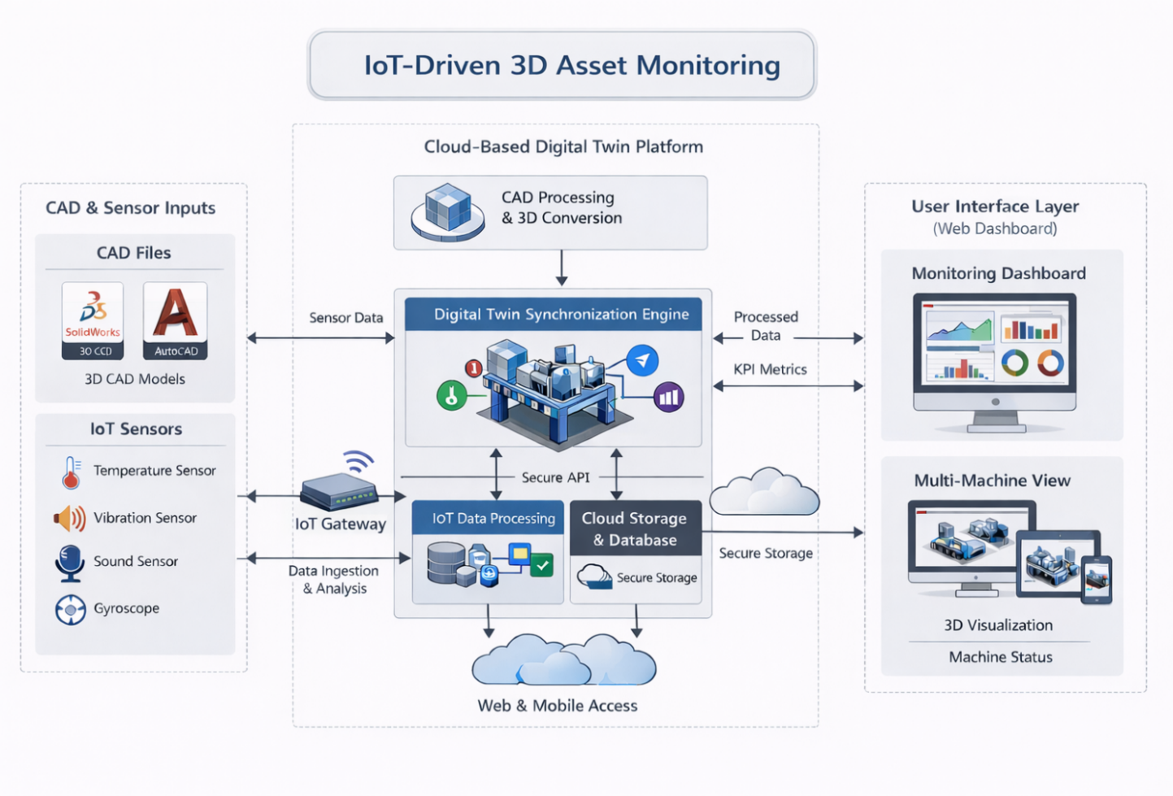

Tools and Technologies
The proposed system can be implemented with use of the software applications and cloud-based architecture. Internet of Things (IOT) is incorporated to enhance this platform.

At the beginning the models of the industrial machine are generated with use of CAD applications like SolidWorks and AutoCAD. With help of the tools Mechanical engineering teams of any corporation are able to create exact representations of assets with detail that can be directly used in digital twins of the machinery.

The optimization and rendering 3D models is performed using software like Blender. CAD models with the high-resolution are converted into lightweight 3D models which can be displayed on the web-platform as well as in 3D real-time rendering without losing structural data.

User's application layer will be designed with using modern web technologies which will make this interface responsive and rich. The technologies will support visualization and data on dashboards of the system. With help of the system's interface users would be able to upload and upload CAD models, view machine status, view measured data from sensors and interact with digital twins.

The server can be created using frameworks and API technologies that can manage sensor data, application logic, and the users. This part of the system receives data from sensors and uploads it to cloud and synchronizes with the digital twin.

All system logic is based on cloud service: AWS can be used for the platform. All files, databases and system processes will be uploaded on the AWS where application can be accessed from any part of the world. Services on the AWS ensure a high availability and security of the platform and give possibility to handle multiple users and large data amounts.

IoT sensors will be installed in the machinery to acquire information like: temperature, acceleration, vibrations etc. All sensors should transmit collected data to server through some of the IoT supported communication ways and the data will be later analysed.

These technologies are selected according to the requirements of the system. AWS, as a scalable and available cloud solution that can handle well data processing for IoT enabled platforms, was chosen. Also, it provides a lot of useful tools and services, which could be helpful. Blender was selected due to its ability to optimize CAD models into highly readable files that will be suitable to be used in web-based rendering system.

Implementation
The implementation of the architecture of Industrial Digital Twin Platform comprises multiple interconnected modules that work together to provide a complete, comprehensive monitoring system.

The first module is the CAD Upload and Processing module. Through this module the user is able to upload machine design files into the system. Then it processes these machines design files into optimum 3D format to be quickly rendered on the virtual space.

The second module is the asset management system module, users can register machines here, provide machine specific identifiers, and also manage machine details in the system. A single machine can be associated with multiple sensor and performance parameters.

This third module is the IoT data integration system. Working data produced from the sensors on the machines are collected via APIs or IoT communication protocols and passed to the backend server where it is used for processing and storing in cloud database.

The fourth module is the digital twin synchronisation engine. In this module, the input of data from sensors is mapped to a certain part of the 3D model. As soon as a value of a sensor is changed, a digital twin will automatically update with this value.

The fifth module is the monitoring dashboard. It shows graphical visualizations (line graph, bar chart, and other analysis plots). Users can easily monitor machine status, analyse the trends of IoT based sensory readings, and operational behaviours in an interactive way.

Synchronization Engine and System Logics
The heart of the system is the synchronization engine, which is used to constantly keep a real time mapping and match between the physical data collected from IoT based sensors and the digital twin model in 3D. The Incoming sensor data are processed continuously, and the 3D model parts related to are continuously updated.

For every new sensor reading, the correct machine is associated with the reading and the specific component of the digital model is identified and assigned the sensor to it. Then the state of the component is dynamically updated with the IoT based sensory readings. When values of sensors go beyond predefined threshold values the system can issue alarms to show the non-normal state.

Core Algorithm
The system works on a continuous data processing. For each incoming stream of sensor data, the system finds out which machine the data is from, and assigns the sensor to a component in 3D model. Then the state of the component is updated according to the value of sensor data, and the visualization is updated in a near real time.

The IoT based sensor readings that exceed the established thresholds result in an alert that is being raised. It is through the recursive cycle that the physical and digital worlds remain in synchronisation.

Sensor-to-Component Mapping
A mapping model is implemented for relating sensor information with particular machine components. For example, temperature sensors with engine blocks with colors, vibration sensors with moving parts with movements, acceleration sensors with moving part with dynamics graph.

Data Processing and Performance Optimisation
The sensor data is processed in batches at fixed intervals in order to maintain optimal performance of the system. The sensor data is received at the backend and stored in a buffering mechanism in order to store the received data temporarily before it gets processed. This increases system throughput by reducing the number of API calls.

The synchronization engine is planned to update the digital twin model every 1-2 sec to have near real-time visualization and no high rendering load on the system. Lightweight JSON format is also utilized and data compression mechanism is employed to reduce latency while sending the data from IoT devices to the cloud server.

Major Findings / Outcomes
The Implementation and deployment of the Industrial Digital Twin Platform prove very advantageous for the industrial asset monitoring.

One of the important outcomes from the system is the integration of the 3D simulation with the real-time IoT sensor data. It makes the users to track down the performance of the machine through the real-time digital replica. Instead of having only numerical based dash-board like before.

Another desirable outcome is improved machine condition monitoring. IoT based real-time sensory data, such as temperature or vibration, allow the machines and equipment to detect anomalous behaviour sooner than traditional methods.

The platform allows checking historical data for the machine performance. This can be helpful in identifying persistent problems and also aids in the formulation of effective maintenance planning methods.

System design, coupled with expected system operational behaviour, is predicted to achieve an increase in the speed of detecting an anomaly in by 20-30% compared to conventional monitoring systems, and instead of periodic and/or manual checking it runs all data in real time with instant notification. Maintenance efficiency should increase by about 15-20% as the fault will be detected and hence be possible to take actions.

The system constitutes latency in synchronisation and accuracy in mapping. The platform aims to provide an acceptable synchronised latency of about 1-2 seconds so that digital twin model updates are made at near real-time. Besides that, the synchronization engine aims at maintaining a mapping accuracy of 90-95% so that sensor readings are appropriately attributed to the related 3D component.

These performance measures are generated based on the system architecture design assumptions, data processing techniques, real-time synchronizing logic and so on, to enhance system responsiveness and efficiency.

Apart from its improved performance, the system shows the direction toward the real-time synchronization of the IoT sensor data to the 3D digital model. The sensor data-driven digital twin update with a synchronization engine and precise sensor to component mapping model reflect the improvement and the advancement over previous monitoring systems.

Overall, the proposed implementation displays the effectiveness of digital twin technology in enhancing the industrial monitoring in real time, improving visibility operationally, and supporting decision-making processes in a more efficient and better way.

Conclusion and Future Scope

The Industrial Digital Twin Platform proposed in the project offers an efficient mechanism for monitoring and managing industrial assets in real-time. The system synchronizes 3D digital models of machines and the current status of their behaviour using real-time IoT sensor data.

Machine monitoring is made better with the help of presentation of the critical data through interactive visuals and dashboards. Engineers and operators will have access to a thorough performance visibility and a way to trace the anomalous conditions and observe operational trends which improves decision making ability of the organizations. Downtime and cost of maintenance will be considerably minimized.

Although, the present system like Siemens Digital Twin provides a robust starting point for digital twin implementation, there are many possible avenues for improvement. A major enhancement can be an automatic alerting and notification system in real time.

An additional potential feature is improved data storage and management system. While the current platform uses cloud-based storage, our later implementations can include more specialized and optimised time series database and data warehouse techniques to handle the mass industrial data efficiently. This can ensure effective analysis of history and better support for predictive analysis.

The platform can also be enhanced with intelligent analysis and machine learning. By processing historical patterns of the sensor data, it's able to foresee possible system failures and to take the predictive measures to minimize downtimes and expenses.

Another possible extension of the framework would be the introduction of an augmented reality/ virtual reality (AR/VR) interface, allowing an immersive interaction with the digital twin modelling. The framework could also be extended to manage an industrial ecosystem of many machines/production unit in one integrated monitoring tool.

The project contributes deeply in the domain of industrial monitoring, the research develops an intelligent real-time analytics framework as well as a structural synchronization mechanism, a sensor-to-component mapping model to greatly increase the usability and accuracy of digital twin platforms.

In addition, the platform has a light CAD-to-3D optimization pipeline. This process makes it possible to achieve Web based 3D viewing and manipulation. Most existing monitoring system uses mostly numerical value-based display. The system provides a combination of real-time monitoring and interactive display system that can improve the system usability and operation effectiveness.

With all these contributions combined the efficiency of the digital twin platform and its importance in contemporary Industry 4.0 applications is ensured. Further development would turn it into an interesting platform to be used in the areas of smart manufacturing and advanced industrial automation.

References

- Amazon Web Services, AWS IoT Documentation: https://docs.aws.amazon.com/iot/latest/developerguide/aws-iot-how-it-works.html
- SolidWorks, CAD Design and Engineering Modeling Documentation: https://help.solidworks.com
- Blender Foundation, Blender Documentation: 3D Modeling and Rendering Software: https://docs.blender.org

